1: Investigate and Plan (600 words)

1.1: Introduction:

'automated home'; a smart home provides homeowners with secure, comfortable, convenient, and energy-efficient living quarters and allows its residents to control the available smart devices via a smart home app installed on their smartphones or other networked devices.

"Alexa…", "Siri...." or "Hey Google...", tapping into a world of opportunity powered by cutting-edge tech in their homes.

Smart homes are part of the Internet of Things (IoT), where smart home devices and systems often operate together. Such devices and systems share consumer usage data among themselves and execute automatic actions as based on the homeowner's preferences.

Some statistic in relation to rising energy cost, Carbon emission, Disability and Smart home market investment in billions.

|  |  |
| --- | --- |
| <https://www.seai.ie/data-and-insights/seai-statistics/key-statistics/prices/>  The stat shows that energy Average electricity price to households has been significantly increased within last 10 years. |  |
|  | The graphs shows that the Co2 emissions worldwide has been increased by +1% in Ireland.  https://ourworldindata.org/co2-emissions#:~:text=In%201950%20the%20world%20emitted,34%20billion%20tonnes%20each%20year.  In 10 years.. |
| Disability Stat: | Use the Ireland Graphs:  https://www.cso.ie/en/releasesandpublications/ep/p-cp9hdc/p8hdc/p9tod/ |
| Forecast Smart Home Market worldwide  https://www.statista.com/topics/2430/smart-homes/#dossierKeyfigures |  |

**Existing Solution:**

|  |  |  |  |
| --- | --- | --- | --- |
| Company | Products/Function | User | Website |
| The Google Nest Learning Thermostat (2022) | Adjusts temperatures to optimal levels | General population | https://store.google.com/product/nest_learning_thermostat_3rd_gen |
| Alexa Smart Home | make it easy to control smart-home devices using voice commands | General population |  |
| Lilli | Web-based interface monitors behaviours | People self-limiting conditions | https://www.intelligentlilli.com/ |
| Hunter Fans | Smart ceiling fan, motion sensor integrates with thermostat. | General Population | https://www.hunterfan.eu/ |
| Security.org | Automatic control of electronic devices | General population | https://www.security.org/resources/smart-home-automation-guide/ |

**Plan and outline Solutions to the brief:**

|  |  |  |
| --- | --- | --- |
| Planned Solutions: | User | Objective: |
| Smart Fan | Disable, Require assistance, General public |  |
| Smart Lights – Web-based control | General public |  |
| Remote Activated Light | General public |  |
| Auto Windows | General public |  |
| Smart Doors | Disable, Require assistance, General public |  |
| Water Level Alarming | Disable, Require assistance, General public |  |
| Intruder Detection | General public |  |

**Potential Stakeholders:**

As a result of the above research and with the support of data, our aim is to reach out to disabled, older, toddlers, and anyone who needs assistance or struggling for self-care as well as the general public in large. The solution will be safe lives and/or reduce the reliance and improve life. While keeping an eye on the cost-effective solutions and helping to reduce the carbon emissions and to save the cost of the rising energy costs.

**Social Implications:**

The purposed solution will help disabled peoples and everyone who require assistance or struggles with self-care an

Save the life, cost and reduce the carbon emissions.

After carefully analyzing the stat and existing products within the market our focus would to provide a cost-effective solution such as

**Refine, list, and describe the objectives for the artifacts that you will develop:**

|  |  |  |  |
| --- | --- | --- | --- |
| Proposed Solutions | Artifacts | Objectives | Technical Solutions: |
| Website | Website | Interactive websites with live Graphs, Analytical Stat, Web-based On/Off using the firebase database. |  |
| Auto Fan- Heat sensing | MicroBit | Auto Heat sensor fan . This will automatically turn on./off based on the defined temperature. This solution will not only disables people, or people with day-to-day needs or struggles with self-care but will be beneficial to the toddlers and the general public. |  |
| Auto Lights controlled via web | MicroBit IoT | Auto Web-based lights are on-off. The solution will save life, cost and reduce carbon emissions. This solution can be used by anyone who has access to the web. Just log on and turn. off the devices no matter where you are. The solution will also prevent any occupational damages by leaving the applicable on. |  |

2: Design (600 words)

|  |  |  |
| --- | --- | --- |
| Artefact | Design Requirements: | Programs language /Technical components |
| Website | As part of this project, we have decided to create a minimum of 6 pages.  Home  Product  Product Detail  Login  Register  Statistics  MicoBit Controller | Programming features:  HTML,  Firebase databases  Python,  JavaScript  CSS,  bootstrap bundle min js  bootstrap bundle CSS |
| Overview:   The objective of the website would be to create different pages.  The database will  The graph.  The validation rules  Demo will  Video will be embedded  Turn the on/off button | | |
| Website Proposed Sketch: | | |

|  |  |  |
| --- | --- | --- |
| Artefact | Design | Programs language /Technical components / Material |
| Auto Fan |  | MicroBit Sensor.  1 x Fan  1 x Micro:bit  1 x USB cable  5 x Breadboard Jumper  Analog Temperature Sensor |
| Description:   The room will be at a high temperature when the temperature is higher than 30° and make people feel uncomfortable. The temperature sensor will send this signal to the Micro:bit, and Micro:bit will send this signal to the Fan. Then, the Fan will drive until the degree of room under 30° to keep a room at a comfortable temperature.  This module is based on the working principle of a thermistor (resistance varies with temperature change in the environment). It can sense temperature changes in its surroundings and send the data to the analogue IO in the Arduino board. | | |
| Data flow diagram: https://lh3.googleusercontent.com/GiZN-Eest9HhqzgJsd6ruRryqMciC0zVBaSuOQGaMLfdWwQnSpO8LZUNJ7qFc90fYt827yw9wINgeTdNJA3tt8HYJk5m1GsN-98_gIc7SM0zAXH3zxj-bZrbAm8sH3VWIjbxOr-o | | |
| System architecture diagram/ Flowchart  https://lh5.googleusercontent.com/HQm259EToeRzfdKf3u7FG3_1Z6cEin0ORJb1jcWgoc4rU3VvCHk-OABSCr-5YxCjF-qceRMAS3pTtQ2hdjA2qOk1Mb8S1NFMLfFxR4OJGGs1Jlr2In5vUuHApYIQTfGiZDx2UUDn | | |

|  |  |  |
| --- | --- | --- |
| Artifact | Design | Programs language /Technical components |
| Auto Light – IoT | Micro:bit Controller | IoT:bit for Micro:bit  1 x Micro: bit  1 x USB cable |
| Description:   The objective to create a On/Off button to be controlled by the website, and this will in turn On/Off the lights.  IoT: bit is an expansion board based on IoT for Micro:bit. It uses ESP8266 as a WIFI expansion board and serial port to communicate with Micro: bit. | | |
| Data flow  https://lh3.googleusercontent.com/XSDdPMazMZ5TlDS2us54gw7gj8g5RxiVwD8niZFmznyle-eA9JA2MObGaY26BnSIunh6B-YocDSfNvYh8ogTuywrNIPnjm2cwcUayPWzQwNq6EvVXr_qMg4-BBotlzp3ZwZcZkDS | | |
| System architecture diagram/ Flowchart  https://lh4.googleusercontent.com/xWH7huoXdzMCpiEqoZXqNtUL8puTU-eoefzvR6UH3KVCy3tEbZPAKHdrE0cBHfqG09QGnCZE8nJHFQRLhflzTpMkJkW0vR6PLAKSmOabVj7rRV_V1TgZqfJhqCW33JD3oHpOKQn8 | | |

**3: Implementation and Testing:**

**Project Timeline:**

A project start date and the end date was defined and the below project life cycle was used to manage the program from start to finish. .

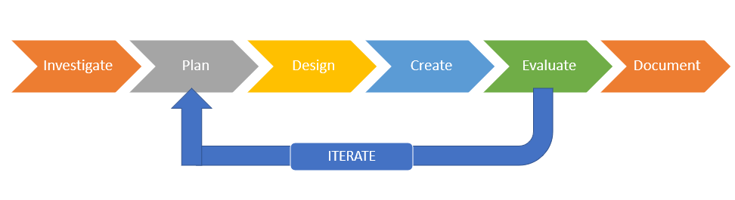

**Investigation Stage:**

In the investigation phase, I aim to capture the details of each user requirement and to understand the scope of the project and how it will be achieved.

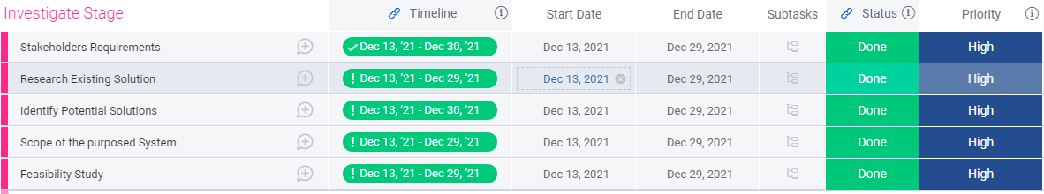

**Plan Stage**

To be replaced…….



Design Stage:

As part of the create stage, I have created the following high-level task. During this stage, my primary focus would be to write the transfer the actual requirements into technical architect design. Where to define the components and programming language, tools, API for the create stage.

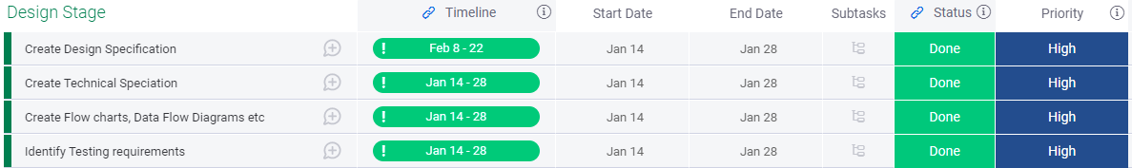

**Create Stage:**

As part of the create stage, I have created the following high-level task. During this stage, my primary focus would be to write the actual program as well as develop the website and database.

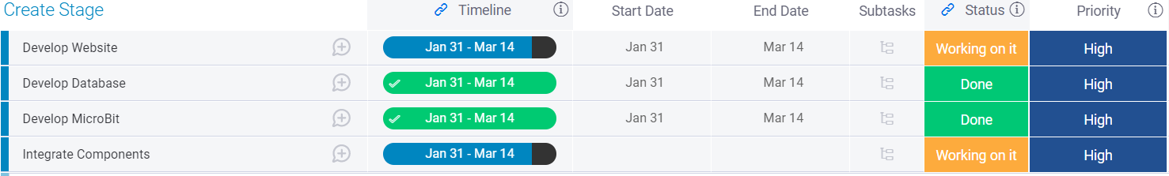

**Evaluation Stage:**

Within the evaluation phase, I have identified the following high-level task. During this stage, I will undertake various testing to make sure that the programs and components work accordingly.

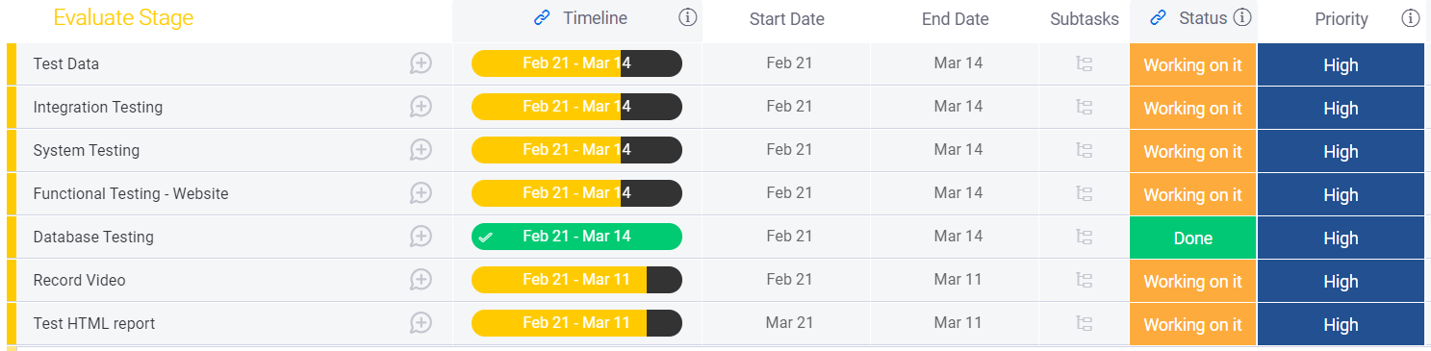

**Document Stage:**

In the documentation stage, the following tasks will be completed. The main purpose of this stage to complete the required documentation and hand it over to the teacher in accordance with project requirements.

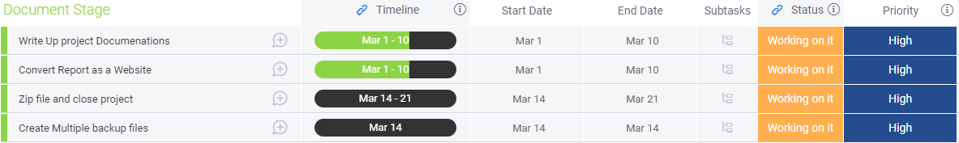

Clearly describe the development of the artifact and any problems that were encountered during the process.

What kind of problem we

demonstrate the operation of the system. This should be

Operation of the system:

There are two set of

You are required a USB port to power the MicoBit device.

The sensor will do

The lights or any device if left attended can be controlled through the

The website has 7 pages. The registration form …

Auto Fan:

|  |  |  |
| --- | --- | --- |
| Auto Fan | 1. I prepare our Micobit hardware  2.We coded the Microbit python  3. Downloaded the code in Microbit  4: Assemble the Microbit device with IoT sensor.  5: Temp sensor connected with the IoT device  6. Collect the room temp and send it to the server (thingspeak) for live data visualization | Picture 1:  Fan with all the cables enabled and show the python code. |
|  |  |  |
| Auto Light | 1: we prepare our hardware.  2: We coded the Microbit with python.  3: Assemble the Microbit device with light.  4: We created a database within the firebase. The purpose of creating the firebase was to check the status of the devices based on the value On/Off.  5: Web page (on/Off) button once clicked the script send data to the firebase.  6: The database is being updated via a webpage. Once the value is turned is set to ON the python script on our computer read the data and control the microbit device as per the value ( if ON the fan will be on else off).  4: we created python scripts to communicate with the firebase server within the microbit.  5: Connected the micro bit with USB within COM3 port.  Note : Problem,,, COM3 port was not opened.  5: we created a web page to control the devices remotely. ( any output device ie Light)  6: The web page update the firebase database and python script read the data and control the device based on the value. ( on/Off)  Firebase works as API… Note | Picture 1: Webpage button section.  Picture 2: Picture with micro bit and IoT separately  Picture 3: Picture with Micro bit IoT assembled with cables attached  Picture 4: Database  Picture 5: Lights On the picture: |

**Fundamental programming skills:**

Please see below an example of programming skills used throughout the project

|  |  |
| --- | --- |
| Programming Skill | Examples |
| Modular approach | Using the modular approach. I developed each unit separately and later complied all of them together. This includes MicroBitt python code, webpages, Registration form, validation rules, Firebase Database, Home page and webpages etc. |
| Functions: Function has been used to enhance the readability and to reduce duplication of a program. |  |
| Algorithms: To achieve the connection with the COM3 port and to collect data from the firebase database we have used the If statement, functions, and loops using the python language. |  |
| Iteration code: We have used a while loop for the Iteration code for refreshing and updating the database. | https://lh5.googleusercontent.com/XXqKA6I9Wb4n0vHDbmPiCZTqYCyru0650iZ1nsUjXLj8vEv9r4ZEIURXMJN67zb7S2LhLZaPTgzHam9IzBLG1-XkR4Bkn2vLiqoEsgBBJm9uNah1HPtAK_-hjEV9W71Nmp6kmVWJ |
| Database Table: I have used the firebase database and created a dataset called "Data".  Creating the database was to store the value On/Off from the web to the cloud firebase database. This will allow the value to be changed instantly. The micro bit will connect via the COM port, detect the database's value, and operate accordingly. If the property's value is set to ON, the light will remain On until changed to Off. | https://lh3.googleusercontent.com/4pnPmRC41mtuiZkEmoT7Yk7TKkQG3h0WDnx4jtUWa0QjbC6AbVHJzxpXXWfqCL8eDC78C7V7prxtOH3NgJ91V4efOdUJUzvnb5-039LP0wEPvs9xbEDM1QFp66ED_vTQnHh2RoXYW |
| Code Structure | Indents were created. The following software were used to programme the codes.  PyCharm, Visual Studio, Makecode, Firbase, BootStrap, etc |
| Data Types: Datatypes such as Strings were used through the programming. |  |
| Comments: Where possible, the programme code is commented. |  |

**Description and type of testing and User case:**

**Integration Tests**

To verify that all which individual components that were built work together. We encountered the following issues during the testing, which were later corrected. Please see Pre and post-testing debugs and corrective actions.

Website:

|  |  |  |  |  |
| --- | --- | --- | --- | --- |
| Test Case | Result (Pass/Fail) | Pre - Corrective Action screenshot/ debug | Post –Corrective action | Post Result (Pass/Fail) |
| At the top, click on links to different pages. Verify that the relevant page opens by clicking on each page. | Fail |  | The page link was fixed after correcting the reference and also by adding a new page, MicroBit Controller, which was missing so that graphs, data, and an on/off button could be viewed. | Yes |
| From the "Register" page please enter the password within the password filed. Passwords must contain one uppercase, numeric, special character, and lower case, and this is to validate that the password must meet the minimum requirement. | Pass | The alert was generated when the validation rules were violated. See the screenshot below. | N/A. test passed. | Pass |
| Click the Submit button without checking the check box. Note an alert message. The page should be redirected to the Home page without agreeing to the terms and Conditions check box. | Pass | The page | Id Tag error was corrected, and the checkbox function and alert message worked perfectly. | PASS |
| Complete the registration form and submit it. Check for the alerts and redirect messages. | Fail | The web page generated the alert message however didn't redirect to the home page. | The "window.location" object used to get the current page (URL) and to redirect the browser to the index page. | PASS |

System Testing and functional testing:

System attesting was carried out to ensure that the whole system fulfils the initial requirements such as turning on/off the lights through the webpage. Function testing was carried out to ensure that its function works correctly. Such API testing was carried out to make sure that graphs' were updated.

|  |  |  |  |  |
| --- | --- | --- | --- | --- |
| Test Case | Result (Pass/Fail) | Pre - Corrective Action screenshot/ debug | Post –Corrective action | Post Result (Pass/Fail) |
| Firebase Database testing. Check that database shows the value of On? Off once the button is clicked from the website. |  |  |  |  |
| Test that the light can be turned on and off from the web page. |  |  |  |  |
| This is to check that the Fan automatically turns off once the temperature reaches to the defined temperature within the Microbit code. | Fail |  |  | Yes |
| Check that the Graphs display the live Temperature data variation. | Fail |  |  |  |
| This is to verify that the Graphs shows the Monthly, weekly and daily data while clicking the Monthly, Weekly and Daily buttons form the webpage. |  |  |  |  |
|  |  |  |  |  |

Acceptance Testing:

|  |  |  |  |  |
| --- | --- | --- | --- | --- |
| Test Case | Result (Pass/Fail) | Pre - Corrective Action screenshot/ debug | Post –Corrective action | Post Result (Pass/Fail) |
|  | Pass |  |  | Yes |
| IoT testing – WiFi Change the password embedded within the micro bit and note the error message. | Fail |  |  |  |
| COM3 port:  This is to make sure that the connection is established and the COM3 port is open. |  |  |  |  |
| In this step, we will verify the initial and backup files of the Zip file are protected by a password. After the program and files are saved on any local machine, they will work according to instructions. | Pass | We created two Zip files and encrypt them. Both files were tested on our local machine, on the school machine, and by the teacher. No issues were found and both worked properly. Please note that all laptop and desktop computers must have the most up-to-date web browsers. | No action is required. | Yes. |

**4: Evaluation (300 words)**

Need text herer………………………….

**5: References:**

|  |  |
| --- | --- |
|  | <https://www.seai.ie/data-and-insights/seai-statistics/key-statistics/prices/> |
|  | <https://www.seai.ie/data-and-insights/seai-statistics/key-statistics/prices/> |
|  | <https://www.seai.ie/data-and-insights/seai-statistics/key-statistics/prices/> |
|  | <https://www.seai.ie/data-and-insights/seai-statistics/key-statistics/prices/> |

<https://www.seai.ie/data-and-insights/seai-statistics/key-statistics/prices/>

<https://www.seai.ie/data-and-insights/seai-statistics/key-statistics/prices/>

<https://www.seai.ie/data-and-insights/seai-statistics/key-statistics/prices/>

<https://www.seai.ie/data-and-insights/seai-statistics/key-statistics/prices/>

<https://www.seai.ie/data-and-insights/seai-statistics/key-statistics/prices/>

<https://www.seai.ie/data-and-insights/seai-statistics/key-statistics/prices/>

<https://www.seai.ie/data-and-insights/seai-statistics/key-statistics/prices/>

<https://www.seai.ie/data-and-insights/seai-statistics/key-statistics/prices/>